**Business Problem**

Employees are always trying to balance work and home life. Some are also trying to manage the school. Trying to keep track of all that needs to get done for each area along with any special projects.

The *To Do* application will manage and track all the to-dos a person needs to complete for any aspect of their life.

Desired Outcomes

* A single location where employees can track to-do items for the home, work, school, or any other project
* Accurate and timely completion of all tasks necessary.
* No more lost notes tracking what needs to get done
* Improve productivity as to-do items are completed and not forgotten

**Stakeholders**

Interested parties throughout the company will benefit from the *To-Do* application.

| **Stakeholder** | **Value from Application** |
| --- | --- |
| Employees (Users) | Intuitive, easy-to-use interfaces. Access from desktop, tablet, or mobile. Real-time visibility of status through reports in a Workspace. |

**Personas**

Interested parties throughout the company will benefit from the *To-Do* application.

| **Persona** | **Privileges** |
| --- | --- |
| User | Ability to submit new records through the Service Catalog or ServiceNow form and check the status of their existing records. Ability to update existing records and see reports in a Workspace. |

**Inputs**

Inputs (data sources) for the *To-Do* application.

| **Data Source** | **Data Format** | **Frequency** | **Duplicate Data, Okay?** | **What Makes Data Unique? (coalesce)** | **Retrieval Method** |
| --- | --- | --- | --- | --- | --- |
| User input - form | N/A | As needed | No | To do items, etc. | N/A |

Outputs

***To-Do* application outputs.**

| **Format** | **Content** | **Frequency** | **Recipients** |
| --- | --- | --- | --- |
| Data Visualization | To do item | Once Added | Users with access to Workspace |

**Tech Stack that will be used**

Python (Flask),Mysql, React JS.

**Figma (Other Tools which can be used) Intro to this**

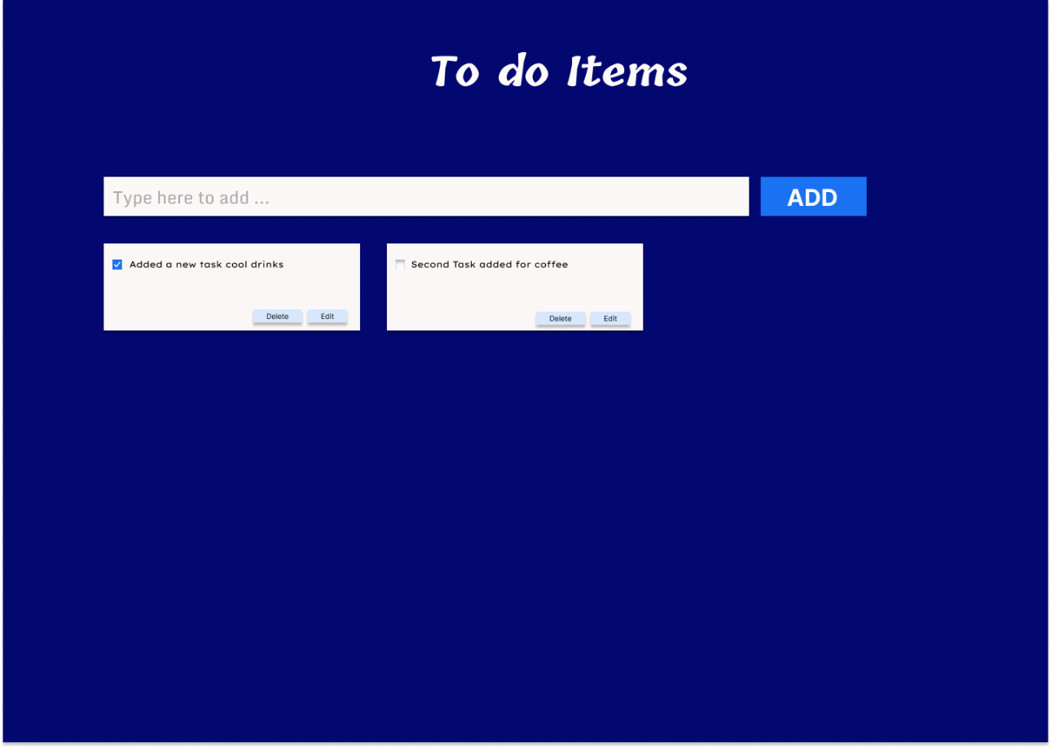

**Data Model**

To do item: Identity what to do; String, Max length 150

Date Modified: task modified the date to be updated

Progress: Indicate the progress for the to-do item; tick mark Completed.

